**Mac Configurator**

1. **Introduction of switching power supply**

The specific meaning of switching power supply is to use modern electronic technology to control the switching time ratio and maintain stable output voltage. With the rapid development of modern electronic technology and the continuous upgrading and improvement of the corresponding architecture, switching power supply has also undergone great changes and development. At present, the switching power supply with the characteristics of small size, light weight, high stability and easy to carry is more popular. In addition, these characteristics of switching power supply make it widely used in many electronic devices.

Switching power supply is an essential form of power supply for the development of today's society. The future development of switching power supply must be high frequency, high reliability, good safety, low energy consumption, less pollution and strong anti-interference ability. At present, many foreign countries make use of the characteristics of switching power supply to continuously develop new high intelligent components. They have more professional technology on the loss of secondary rectifier components, and increase scientific and technological innovation in power ferrite materials to increase high frequency and large magnetic flux density to obtain higher magnetic properties. This paper mainly introduces the Mac 87W USB-C power configurator.

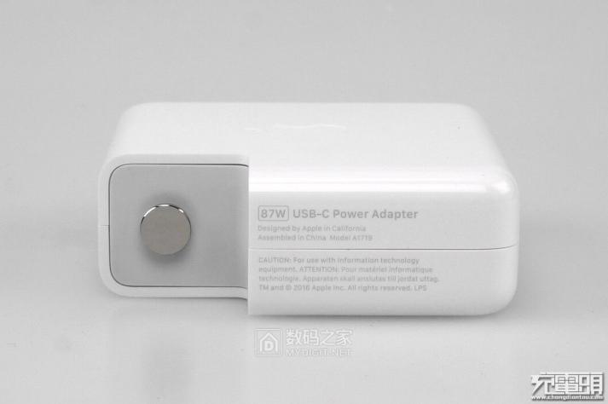

Figure 1 USB-C power adapter

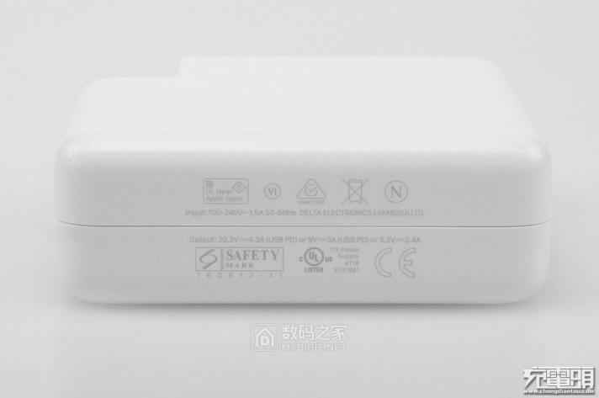

Figure 2 USB-C power adapter

1. **Function, input and output features**
   1. *Basic principle diagram of switching power supply*

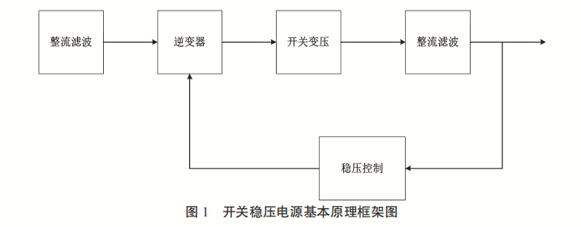

Figure 3 basic principle diagram of switching power supply

* 1. *input and output features*

|  |  |
| --- | --- |
| Input voltage | 100-240V |
| Input current | 1.5A |
| Input frequency | 50-60Hz |
| Output voltage | 20.2/9/5.2V |
| Output current | 4.3/3/2.4A |

1. **Dismantling diagram**

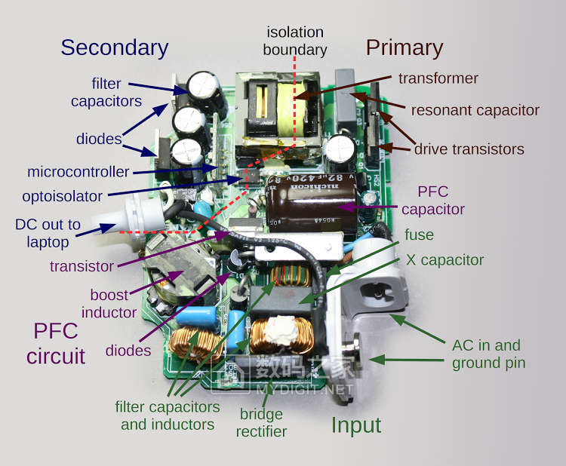

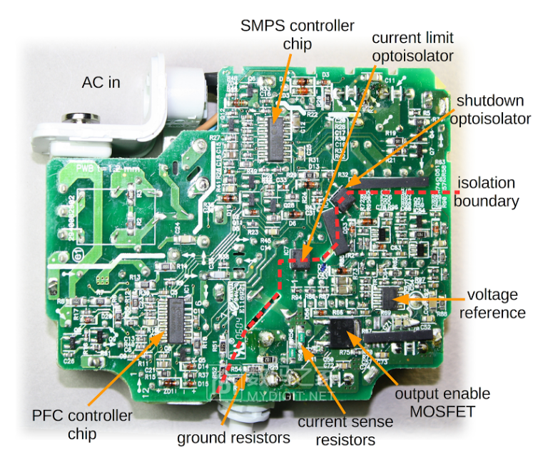

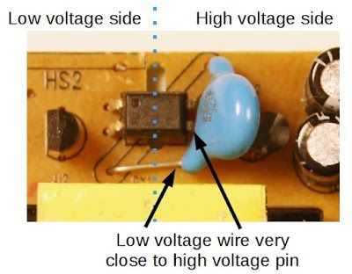

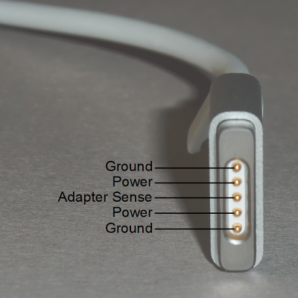

1. **Circuit diagram and device function description**

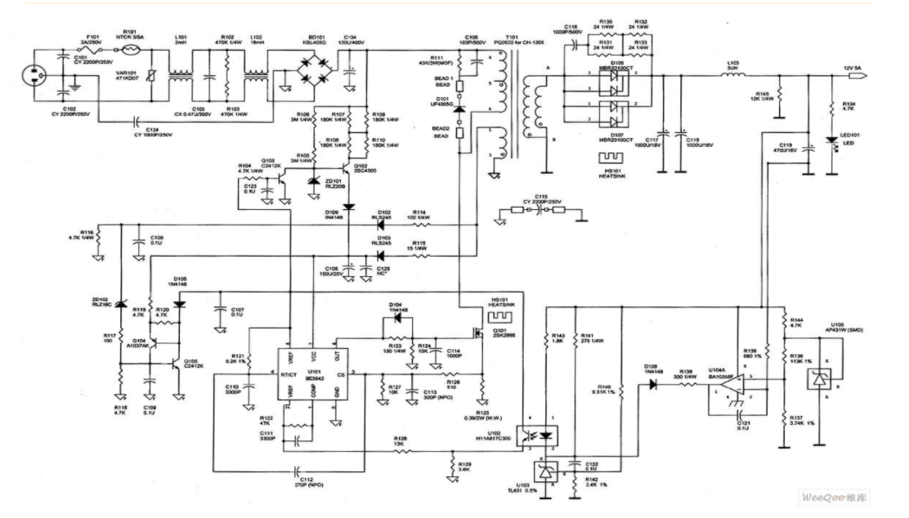

(General circuit diagram)

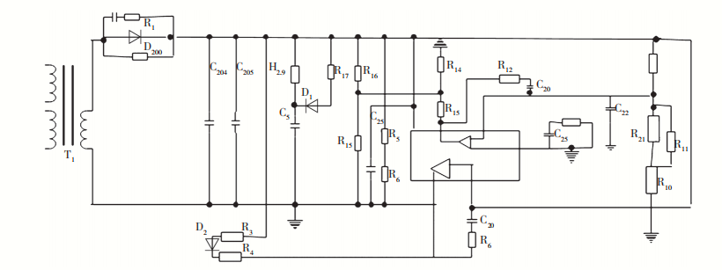

(Control circuit schematic diagram)

(1) Varistor. When the voltage reaches a certain height, the value of varistor will be adjusted rapidly, and its value will become infinitely small. The fuse in series in the circuit will be quickly blown, and other components in the circuit will be well preserved.

(2) Inductance coil. Inductance coil is mainly used to reduce battery interference.

(3) Rectifier bridge. The main function of rectifier bridge is to convert 220 V alternating current into direct current.

(4) Filter capacitor. The main function of the filter capacitor is to filter out the AC wave in the direct current to ensure the safe and reliable operation of the circuit.

(5) Temperature probe. The temperature probe is used to detect the operating temperature of the power adapter. When the working temperature of the power adapter reaches a certain temperature, the temperature probe will automatically cut off the output current to ensure that other components in the adapter are in good condition.

(6) High power switch tube. High power switch tube is an important part of switching power supply in the project, and its function is to control the switch.

(7) Switching transformer. Switching transformer is one of the core components of switching power supply.

1. Secondary rectifier tube. The main function of secondary rectifier is to convert low voltage alternating current into low voltage direct current.
2. **Component**

Rectifier diode:

Rectifier diodes are generally planar silicon diodes, which are used in various power supply rectifier circuits.

When choosing rectifier diodes, the maximum rectifier current, maximum reverse working current, cut-off frequency and reverse recovery time should be considered. Rectifier diodes use the unidirectional conductivity of PN junction to change alternating current into pulsating direct current. The leakage current of rectifier diodes is large, and most of them are packaged with surface contact materials. The maximum rectifier current refers to the maximum current value allowed by the rectifier diode for a long time. It is the main parameter of the rectifier diode and the main basis for the selection of rectifier diode.

Rectifier diodes used in rectifier circuit and pulse rectifier circuit of switching regulated power supply should be those with higher working frequency and shorter reverse recovery time (such as RU series, EU series, V series, 1SR series, etc.) or fast recovery diodes.



